**Routing in React**

What is routing ?

= routing means creating a link in the home page and go to a page using that component .

How we can use routing?

= 1st to use routing , go to the terminal and install react-router-dom



Then go to package.json to check if the react-router-dom is installed or not

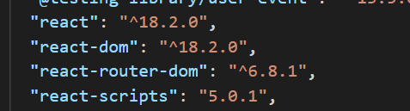

2nd we create some pages component

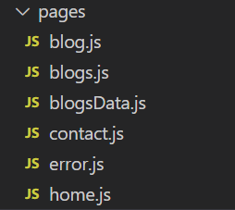

3rd , After that go to the app.js and there insert the code

import React from 'react'

import { BrowserRouter, Route, Routes } from 'react-router-dom'

import Home from "./component/pages/home"

import Blogs from "./component/pages/blogs"

import Contact from "./component/pages/contact"

import Error from "./component/pages/error"

import Navbar from './component/navbar/navbar'

import Blog from "./component/pages/blog"

export default function App() {

  return (

1st create a BrowserRouter tag from react-router-dom

    <div>

        <BrowserRouter>

          <Navbar/>

Inside the bowserRouter tag create a Routes tag

<Routes>

Declare a path to which component we want to browse

Inside the Routes tag create a route tag to declare which component we want to route

            <Route path='/'  element={<Home/>}/>

            <Route path='/contact' element={<Contact/>} />

            <Route path='/blogs' element={<Blogs/>} />

            <Route path='/blogs/:title' element={<Blog/>} />

            <Route path='*' element={<Error/>} />

In Route tag we declare element to which component we want to show in the path

          </Routes>

        </BrowserRouter>

    </div>

  )

}

***Show details:***

<Route path='/' element={<home/>} /> means in localhost:3000 we want to show home component

<Route path='/contact' element={<Contact/>} /> means in localhost:3000/contact we want to show contact component

<Route path='/blogs' element={<Blogs />} /> means in localhost:3000/blogs we want to show blogs component

***Note***: <Route path='*' element={<Error/>} /> That means if we go any routes that is not valid then error component will appear

**useLocation**

**what is useLocation?**

= useLocation is a react hook to use dynamic routing

**How we can use useLocation for Dynamic Routing?**

1st , create a Link tag from react-dom-router then in the blogs.js

import React, { useState } from 'react'

import { Link } from 'react-router-dom';

Get data from blogsData

import { blogsData } from './blogsData'

export default function Blogs() {

    const [blogsdata, setblogsdata] = useState(blogsData);

    let transcate=(str,num)=>{

Create a transcate function to slice a string

        if(str.length>num)

        {

            return str.slice(0,num)+"...."

        }

        else

        {

            return str

        }

    }

  return (

    <div className='alldivs'>

Mapping the blogsData

        {

Distructure the data as id, title,body

            blogsdata.map((data)=>{

                let {id,title,body}=data

                return <div key={id} className="singleDiv">

                   <h3>{title}</h3>

                   <p>{transcate(body,50)}</p>

                  <Link to={title} state={{id,title,body}}  >Learn more </Link>

                </div>

            })

Create a Link tag and there send to={title} and also send id,title,body as state

        }

    </div>

  )

}

2nd , After that go to the app.js and write the code in the Routes tag:

 <Route path='/blogs/:title' element={<Blog/>} />

3rd , After that go to blog page and write the code bellow,

And here we use useLocation

import React from 'react'

import { useLocation } from 'react-router-dom'

export default function Blog() {

Here we declare useLocation hook in the location variable

  let location=useLocation()

  return (

    <div className='singleBlog'>

Here we can get the id,title,body from location.state

        <h1>{location.state.title}</h1>

        <p>{location.state.body}</p>

    </div>

  )

}

Output : Show the output in the site

<https://uselocationusing.netlify.app/>